



Essay / Assignment Title: Time Series Forecasting: A Practical Approach to Data-Driven Energy System Analysis

Programme Title: MSc Data Analytics

Name: Hemanth Kumar Thekkeillam

Year: 2026

CONTENTS

CONTENTS 2
INTRODUCTION 5
DATASET DESCRIPTION 7
CHAPTER ONE: EXPLORATORY DATA ANALYSIS (EDA) 9
1.1 Descriptive Statistics 9
1.2 Correlation Heatmap 11
1.3 Frequency Distribution Analysis 12
CHAPTER TWO: DATA PREPROCESSING AND FEATURE ENGINEERING 14
2.1 Inconsistency in the data type 14
2.1.1 Identifying the Issue 14
2.1.2 Severity of the Issue 15
2.1.3 Ways to Handle the Issue 15
2.2 Minor Missing Values After Conversion 15
2.2.1 Identifying the Issue 15
2.2.2 Severity of the Issue 16
2.2.3 Ways to Handle the Issue 16
2.3 Distribution and Outlier Considerations 17
CHAPTER THREE: MODEL DEVELOPMENT AND EVALUATION 18
3.1 Correlation Analysis with Target Variable 18
3.2 Model Development 19
3.3 Performance Comparison of Model 19
CHAPTER 4: BUSINESS RECOMMENDATIONS AND FORECASTS 22
4.1 January 2026 Forecast 22
4.2 Business Implications 23
4.3 Confidence Level and Limitations 23
CONCLUDING REMARKS 24
BIBLIOGRAPHY 25
APPENDICES 26
Task 1 26
Appendix 1: Loading the Dataset 26
Appendix 2: Calculating Descriptive Statistics 27
Appendix 3: Correlation Heatmap 27
Appendix 4: Frequency Distribution Plots 28
Task 2 28
Appendix 5: Handling Column Formatting and Numeric Conversion of Columns 28
Appendix 6: Handling Missing Values 28
Task 3 28
Appendix 7: Train-Test Split (80/20) 28
Appendix 8: Linear Regression Model 28
Appendix 9: Calculating R2, MAE, MSE for Linear Regression Model 29
Appendix 10: Random Forest Regression Model 29
Appendix 11: Calculating R2, MAE, MSE for Random Forest Regression Model 29
Appendix 12: Train-Test Split (70/30) 30
Appendix 13: Comparing Two Models Through Graphical Representation 30
Task 4 30
Appendix 14: Extracting January Data 30
Appendix 15: Calculating January Annual Weather 31
Appendix 16: Predicting January 2026 31
LIST OF TABLES AND FIGURES 32
GOOGLE COLAB 33

Statement of compliance with academic ethics and the avoidance of plagiarism

I honestly declare that this dissertation is entirely my own work and none of its part has been copied from printed or electronic sources, translated from foreign sources and reproduced from essays of other researchers or students. Wherever I have been based on ideas or other people texts I clearly declare it through the good use of references following academic ethics.
(In the case that is proved that part of the essay does not constitute an original work, but a copy of an already published essay or from another source, the student will be expelled permanently from the program).

Name and Surname (Capital letters):

HEMANTH KUMAR THEKKEILLAM

Date: 03/03/2026

INTRODUCTION

The worldwide shift to renewable energy sources now requires an accurate forecasting model that can predict energy production under different environmental conditions. Solar energy needs meteorological factors because its output depends on sunlight intensity, temperature, rainfall, cloud cover, daylight changes in various season. These different changing conditions create unpredictable energy production patterns which make predictive modelling an essential requirement for contemporary energy management systems and planning systems.
Time series regression provides a structured analytical framework for examining historical patterns and estimating future values of continuous variables. Forecasting energy accurately enables effective grid management systems, resource allocation, storage optimization and long-term investment planning. Forecasting inaccuracies can lead to operational inefficiencies, financial loss, and supply–demand imbalances (Hyndman and Athanasopoulos, 2021). The use of statistical and machine learning models on renewable energy datasets produces both practical and academic value.
Modeling techniques based on regression are widely used for prediction purposes. The Linear Regression model provides a theoretical model based on statistics that enable users to understand the relationship between predictor and response variables. The energy systems in the real world are nonlinear because environmental factors interact in a way that produces a result in an unpredictable manner. The Random Forest Regressor model uses an ensemble-based approach for modeling a nonlinear relationship that produces a better result in terms of accuracy because of the combined output of multiple decision-making processes (James et al., 2021).
The report aims to analyze a dataset related to solar energy that contains time-series values for a time interval of 15 minutes between 2017 and 2022, with more than 10,000 values. The dataset includes environmental predictor variables and a continuous target variable, Energy Capture, which shows the solar energy output that was measured during each time interval. The analysis consists of four parts which begin with exploratory data analysis to assess statistical characteristics and data relationships. The second part of the process involves data preprocessing which handles missing data and other problems. The third step develops regression models which will be evaluated before the final step forecasts average energy production for January 2026.
This research study shows how statistical reasoning and model assessment together with business understanding can be integrated to solve renewable energy forecasting challenges using basic data analytics techniques that meet postgraduate analytical requirements.

DATASET DESCRIPTION

The dataset for this study is a time series dataset for solar energy. The time series dataset contains values for each 15-minute interval between the years 2017 and 2022. The structured nature of this dataset is appropriate for regression-based forecasting analysis because it is possible to analyze patterns and relationships for sequential time points.
The dataset contains over 10,000 values. The number of samples in this dataset is appropriate for conducting a statistically significant analysis. Having a large number of samples in a dataset is useful for model generalization and for reducing the risk of overfitting when comparing different predictive models.
The main variable of interest in this analysis is the Energy Capture. The Energy Capture refers to the amount of energy that is captured during each interval. This variable is a continuous numerical value and thus appropriate for regression-based analysis rather than classification-based analysis. The purpose of the modeling process is to determine future values of this variable based on environmental factors.
The dataset includes the following key features:
- Time: Indicates the date and time of each measurement
- Energy Captured [Wh]: Measures the electrical energy produced in each 15-minute.
- Sun Light Intensity (W/m2): Measures solar radiation exposure
- Temperature: Atmospheric temperature at the time of measurement
- 1 Hour Rainfall: Recorded precipitation level
- Cloud Coverage: Proportion of sky covered by clouds
- Length of Daylight: Duration of daylight hours for the given date
These features are logically appropriate to the production of solar energy. For example, an increase in the intensity of sunlight and the duration of daylight are expected to have a positive effect on the production of solar energy. However, an increase in cloud cover and rainfall is expected to negatively influence the production of solar energy. The addition of multiple meteorological variables is useful in exploring the direct and interaction effects on the production of solar energy.
The rationale for the use of the dataset is the relevance of the dataset in real life in terms of renewable energy forecasting, the number of data points in the dataset for model development and assessment, and the variety of environmental features available for analysis.
The dataset is appropriate for the assignment because its structure is relevant to the application of time series regression techniques in the analysis and forecasting of a continuous target variable in a real-life context related to the energy sector.

CHAPTER ONE: EXPLORATORY DATA ANALYSIS (EDA)

The process of Exploratory Data Analysis was performed to understand the statistical properties of the data and the relationship that exists between the features, which in turn affects the solar energy production process. The dataset has more than 10,000 time series data points, recorded at an interval of 15 minutes, starting from the year 2017 to 2022.

Descriptive Statistics
Descriptive statistics were calculated for all numerical variables, which includes, mean, median, mode, and standard deviation.
Variables | Mean | Median | Mode | Standard Deviation
Energy Captured [Wh] | 573.011262 | 0.0 | 0.0 | 1044.832388
Sun Light Intensity (W/m2) | 32.598451 | 1.6 | 0.0 | 52.175402
Temperature | 9.790703 | 9.3 | 4.8 | 7.995447
1 Hour Rain Fall | 0.066036 | 0.0 | 0.0 | 0.278915
Cloud Coverage | 65.970798 | 82.0 | 100.0 | 36.637595
Length of Day Light | 748.650189 | 765.0 | 1020.0 | 194.867878
Table 1: Descriptive Statistics of Solar Energy Dataset (2017–2022)
The mean of Energy Captured is approximately 573 Wh, the median is 0 Wh, and the mode is also 0 Wh. The indicates that a significant number of data points are reporting zero units of energy produced. This is logical because the solar energy source would naturally produce zero units of energy during the nighttime hours.
The standard deviation of Energy Captured is approximately 1044.83 Wh, which is significantly higher than the mean. The implication is a high level of variability in the generation of units of energy because of the natural daily cycles and changing weather conditions. Such variability is characteristic of renewable energy sources and points to the importance of accurate predictive modeling.
The mean of Sun Light Intensity is approximately 32.60 W/m², the median is 1.6 W/m², which again points to a high level of skewness in the data set. There are a number of data points reporting low values of radiation units, which is characteristic of the early morning or evening hours and/or a cloud cover. There are fewer data points reporting high values of radiation units.
The temperature has a relatively uniform distribution with a mean value of 9.79°C and a standard deviation of approximately 7.99. These characteristics indicate that temperature varies with the seasons.
The rainfall has a very low mean value of 0.066 and a median value of 0. This indicates that rainfall is infrequent but has high impact during specific periods.
The Cloud Coverage has a mean value of approximately 65.97%, with a mode value of 100. This indicates that it is completely overcast during these instances. Cloud coverage has a direct effect on energy production because it blocks sunlight.
The mean value for Length of Day Light is 748.65 minutes, with a standard deviation of approximately 194.87. These characteristics indicate that there is strong seasonal variation. The longer days are likely to have a direct proportionate effect on energy production.
The descriptive statistics indicate that there are strong variations and non-symmetric distributions for several important variables, such as Energy Captured and Sun Light Intensity (Hyndman and Athanasopoulos, 2021).

Correlation Heatmap
To examine linear relationships between variables, a correlation matrix was calculated and visualised using a heatmap.
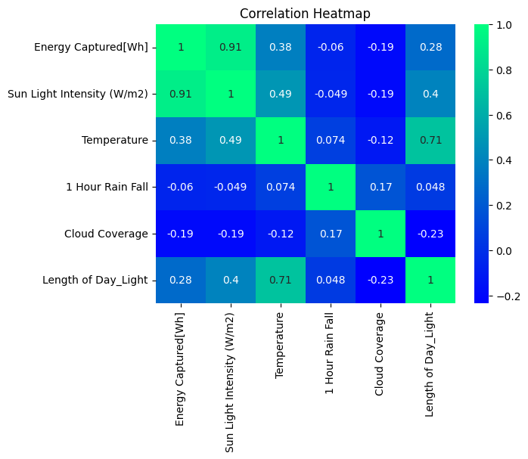
Figure 1: Correlation Heatmap of Solar Energy Variables
The relationship is a function of the seasons, where increased temperatures and longer days equate to increased solar irradiance.
The relationship between the two is a negative correlation, where an increase in cloud coverage leads to a reduction in energy captured, as defined by the correlation coefficient of -0.19.
The relationship between Rainfall and Energy Captured is a minimal linear correlation, where the correlation coefficient is approximately -0.06.
The correlation results obtained demonstrate logical consistency with the nature of solar energy capture mechanisms.

Frequency Distribution Analysis
Frequency distribution charts were generated to analyse the distribution shape of each variable.
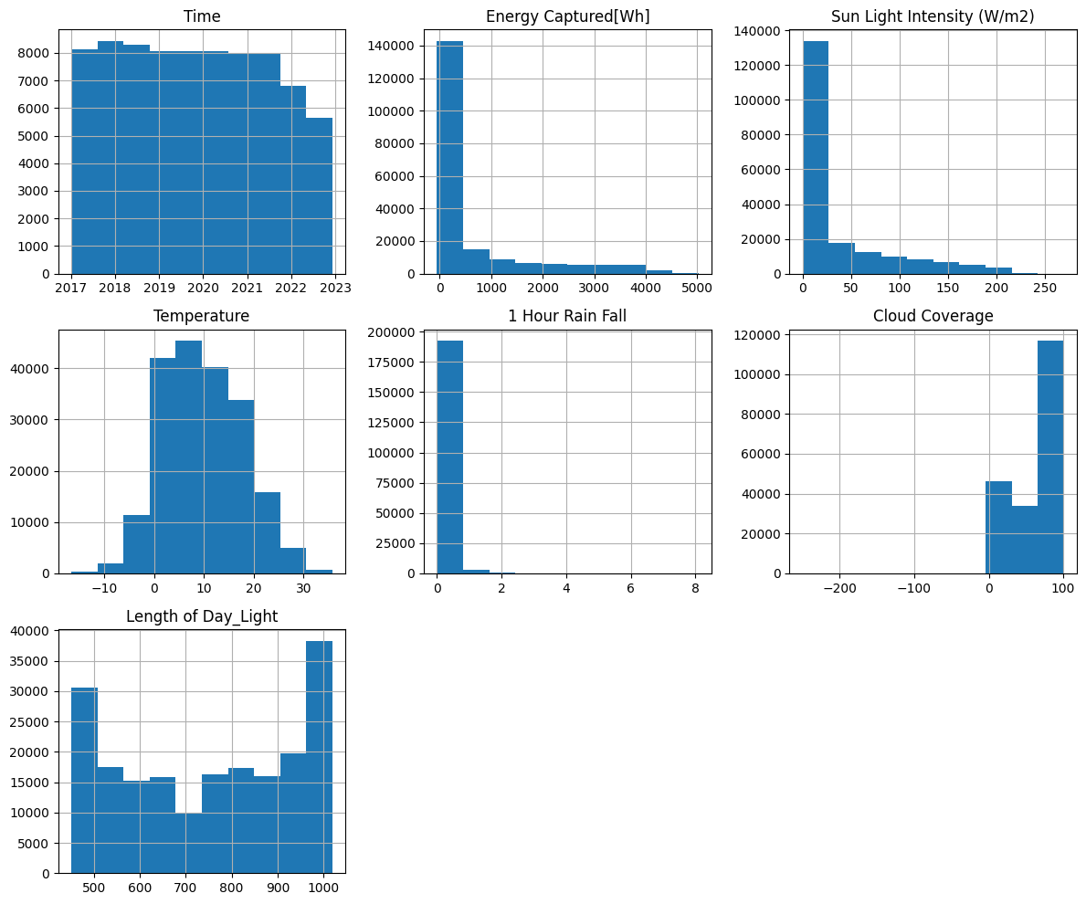
Figure 2: Frequency Distribution of Key Variables
As seen in the histogram for Energy Captured, it is a right-skewed distribution with a large peak at zero and a small peak for high production.
Sun Light Intensity also has a right-skewed distribution, indicating that most intervals have low intensity, with fewer high-radiation intervals. Rainfall has a strong peak at zero, indicating that rainfall is an uncommon event. Cloud Coverage has a strong peak for higher percentages, indicating that it is a common occurrence to have cloudy skies. Length of Daylight has a strong peak for winter and summer.
As seen in these distribution characteristics, it is clear that this data set does have nonlinear behavior and high variance, which would require a regression model that can account for this (James et al., 2021).

CHAPTER TWO: DATA PREPROCESSING AND FEATURE ENGINEERING

The goal of this phase is to prepare the dataset for reliable statistical analysis and regression modeling by identifying and correcting structural issues in the data.
In this preprocessing phase, two major issues were identified:
- Inconsistency in the data type (numeric variables of object type)
- Presence of minor missing values during numeric conversion

2.1 Inconsistency in the data type

2.1.1 Identifying the Issue
Initially, when trying to compute the descriptive statistics, such as mean, median, and standard deviation, the functions returned empty results. Upon examining the structure of the data, it was observed that the data types of the numeric variables were object type, not numeric type.
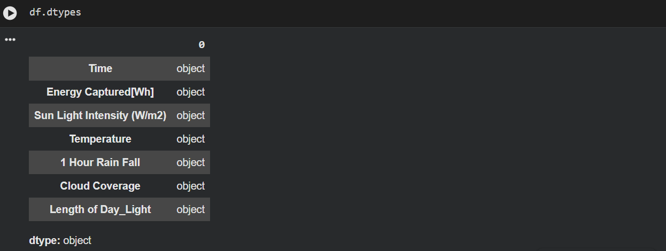
Figure 3: Dataset Data Types Before Conversion
This was a major issue since the statistical functions as well as the regression models require the input to be numeric.

2.1.2 Severity of the Issue
The issue was of moderate to high severity because:
- Descriptive statistical calculations could not be carried out.
- Correlation analysis would not be accurate.
- Regression models using the Scikit-learn library require numeric input.
- Incorrect data types would result in incorrect analytical results.
Therefore, the data types needed to be corrected before proceeding with the analysis.

2.1.3 Ways to Handle the Issue
The column names were first cleaned to remove any spaces that might be hidden, and then the data types of all the columns, apart from the Time column, were converted to numeric.
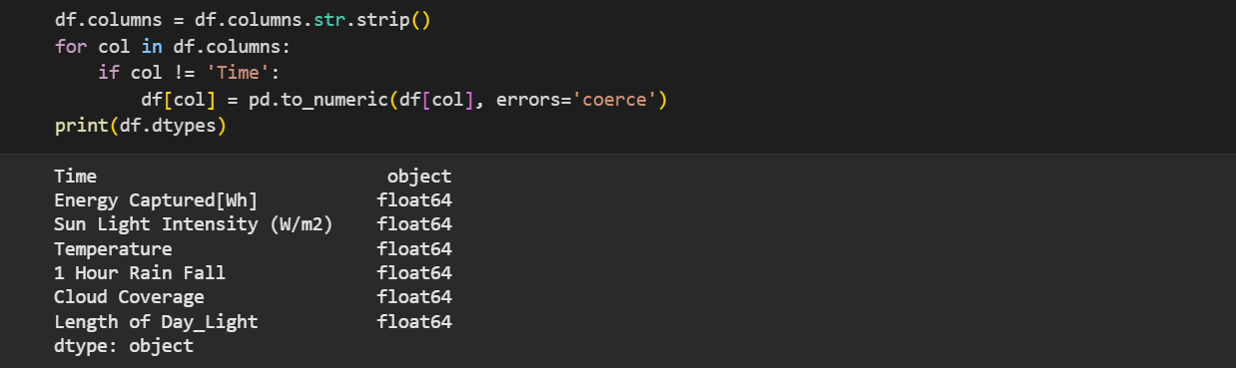
Figure 4: Dataset Data Types After Numeric Conversion
After the correction of the data types, the statistical calculations were successful, which helped to complete the Task 1.

2.2 Minor Missing Values After Conversion

2.2.1 Identifying the Issue
During the numeric conversion, errors='coerce' parameter was used. This ensures that invalid numeric data is converted to NaN. Hence, a few missing values were introduced in the dataset.
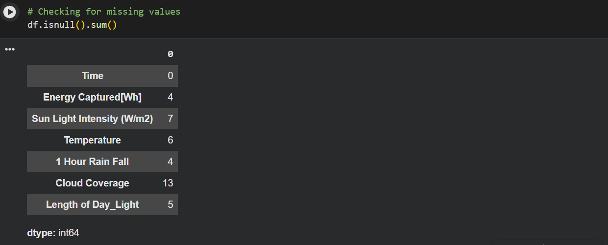
Figure 5: Missing Values Identified After Numeric Conversion

2.2.2 Severity of the Issue
The missing values were very few in comparison to the overall size of the dataset, which was more than 100,000 records. Though the percentage of missing values was very low, they cannot be allowed in the regression model, as the Scikit-learn algorithms cannot handle NaN values by default.

2.2.3 Ways to Handle the Issue
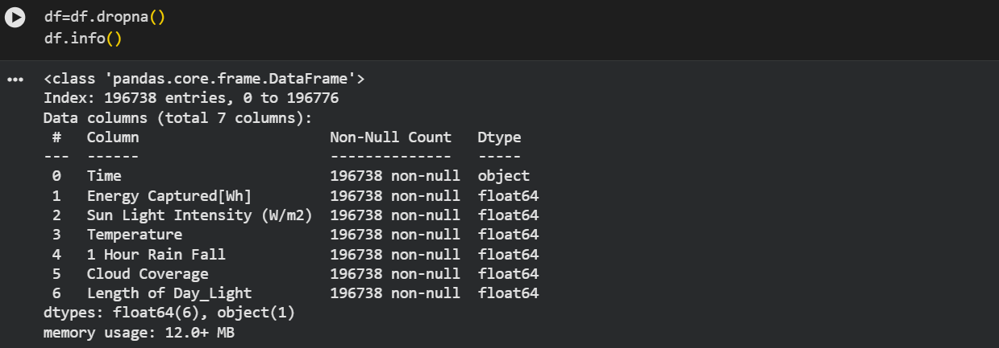
Since the missing values were very few, the best way to handle the issue was to simply remove the rows containing missing values. Therefore, dropna() is used for removing the rows which contains missing values.
Figure 6: Final Cleaned Dataset
The dropna() method was chosen because the percentage of missing values was very low, removing the missing values would affect the overall statistical validity of the data, and there would be no introduction of biases into the data.

2.3 Distribution and Outlier Considerations
For the exploratory analysis in Task 1, it was found that the data set Energy Captured has a highly right-skewed distribution.
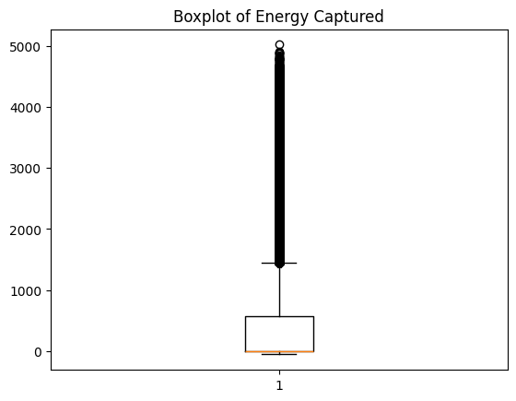
Figure 7: Boxplot Showing Extreme Energy Values
In figure 7, the bloxplot shows extreme values exist in the data set, but these extreme values are actual intervals of high solar production and not due to any measurement error. Hence, no removal of extreme values was done. Later, the issue of extreme values is handled during model selection, especially the use of the random forest regressor model since it is less affected by extreme values compared to linear regression (James et al., 2021).

CHAPTER THREE: MODEL DEVELOPMENT AND EVALUATION

3.1 Correlation Analysis with Target Variable
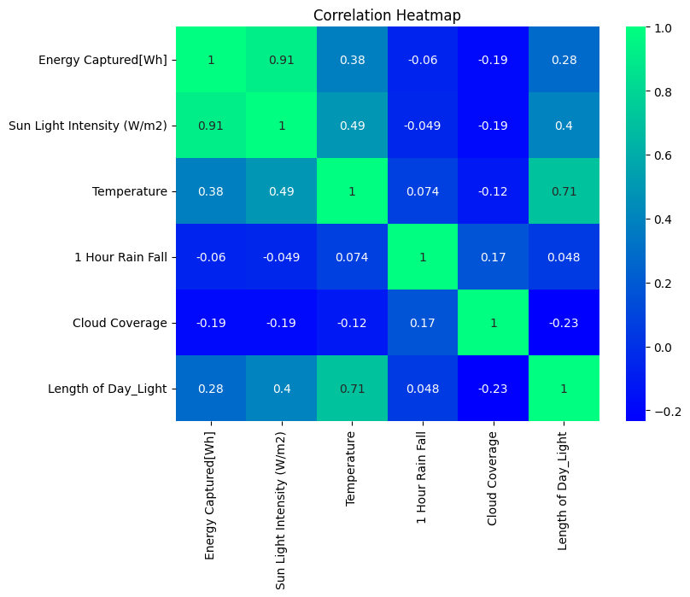
Figure 8: Correlation matrix showing relationships between weather variables and energy captured
The correlation heatmap (Figure 8) was also utilized in the analysis to identify the variables with strong correlation with the energy production. The Sun Light Intensity (W/m²) has a strong correlation (0.91) with Energy Captured [Wh], which is positively related. This is logical because the energy produced is greatly dependent on the availability of sunlight.
The Temperature has a moderate correlation (0.38) with the energy produced. This is logical because the temperature is usually high during the time of the year with high levels of sunlight. The Length of Day Light (0.28) also has a positive correlation with the energy produced. This is logical because the longer the daylight hours, the longer the time the energy is being produced.
The Cloud Coverage (-0.19) and the 1 Hour Rain Fall (-0.06) have negative correlations with the energy produced. This is logical because the energy produced is greatly reduced during the time of the year with high cloud coverage and rain.

3.2 Model Development
Two regression models were implemented:
- Linear Regression Model: This model assumes a linear relationship between independent variables and the target variable (Montgomery, Peck and Vining, 2012).
- Random Forest Regressor Model: This model is an ensemble learning method that builds multiple decision trees and averages their predictions to improve accuracy and reduce overfitting (Breiman, 2001).
The dataset was split using two different train-test ratios (80/20 and 70/30) to evaluate model stability.

3.3 Performance Comparison of Model

Model | R2 | MAE | MSE
Linear Regression | 0.84606 | 240.16606 | 166652.37227
Random Forest Regressor | 0.91548 | 130.90605 | 91500.57763
Table 2: Performance Comparison of Models (80/20 Split)

Model | R2 | MAE | MSE
Linear Regression | 0.84720 | 240.49928 | 165542.52672
Random Forest Regressor | 0.91518 | 131.53277 | 91890.25602
Table 3: Performance Comparison of Models (70/30 Split)
In both split cases, the random forest regressor outperformed linear regression significantly. The R2 score value of the random forest regressor was above 0.91, compared to approximately 0.84 for linear regression. In addition, the MAE and MSE values were much lower which indicates a high level of accuracy in predictions.
The fact that there was a small variation in the results of the 80/20 and 70/30 split, indicates that the data set is sufficiently large, and the models are stable. This indicates low sensitivity to the changes in size of the dataset.
The results of the random forest regressor shows that the relationship between weather variables and energy production is non-linear. Unlike linear regression, random forest regressor can account for all the complexities in the relationship between sunlight intensity, cloud cover, and other environmental variables.
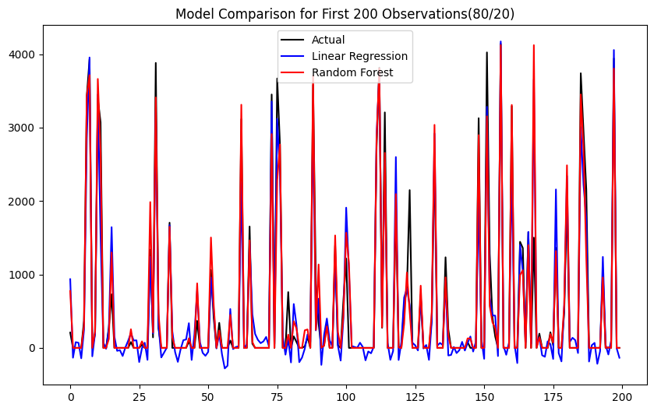
Figure 9: Comparison of actual energy production with Linear Regression and Random Forest predictions (80/20 split).
As shown Figure 9, the random forest regressor model is able to follow the changes in the actual energy production values better than the linear regression model. The deviations in the linear regression model are higher during the peak production times, which shows its limitation in dealing with non-linear data. The random forest regressor model is seen to follow the actual values better, especially during the high variance times.

CHAPTER 4: BUSINESS RECOMMENDATIONS AND FORECASTS

4.1 January 2026 Forecast
The Random Forest Regressor model for 80/20 split was chosen for forecasting based on better performance metrics.
Average weather conditions for the month of January from the years 2017-2022 were used for the estimation of the production for the month of January 2026.
Year | Average January Energy [Wh]
2017 | 180.018737
2018 | 125.365165
2019 | 117.248992
2020 | 122.447245
2021 | 83.167339
2022 | 161.141204
2026 | 161.963750
Table 4: Average January Energy Production Comparison
The predicted average energy production in January 2026 is 161.96 Wh, as shown in the table above. This is similar to the energy levels in January 2022, as discussed in the analysis, and much higher than the average energy levels in the period 2018-2021.

4.2 Business Implications
From the analysis, it is clear that sunlight intensity is the main factor affecting solar energy production. Therefore, solar irradiance forecasting should be a priority in planning.
The stability of the model in performing predictions, as evidenced by the analysis, shows the reliability of the forecasting method.

4.3 Confidence Level and Limitations
The confidence level of the forecasting model is moderate because of the following reasons:
- Strong model accuracy: R2 score value is approximately 0.91.
- Logical consistency of correlations.
- Large dataset size.
The limitations of the forecasting method are as follows:
- Forecasting method assumes stability in historical weather patterns.
- Climate change variables are not included in the forecasting method.
- Technological efficiency improvements are not included in the forecasting method.

CONCLUDING REMARKS

This study utilized time series regression to analyze and forecast solar energy production based on weather-related variables. The exploratory data analysis indicated that Sun Light Intensity(W/m2) is the strongest factor which affects solar energy production, as it has a very high positive correlation with Energy Captured [Wh], with an r2 score of 0.91. Other variables, such as temperature and length of daylight, have moderate positive relationships, and cloud coverage and 1 hour rainfall have negative relationships. All of these findings make logical sense with respect to solar panels and PV systems.
Two regression models, Linear Regression and Random Forest Regressor, were developed and compared. The results showed that the random forest regressor performed better than linear regression, with an R2 score of 0.91, and lower MAE and MSE values. The small difference between the two train-test splits, 80/20 and 70/30, suggests that the model is very stable and not very sensitive to changes in data splits.
Using the better performing model, the forecasted average energy production for January 2026 is approximately 161.96 Wh. This is closer to the January 2022 production levels. It can therefore be seen that the performance is stable compared to the historical trend. However, the forecasted results are based on the assumption that the historical weather conditions in January remain the same. It is not based on any changes in the climate or the efficiency of the technology.
From the analysis, it can be seen that the use of machine learning algorithms, particularly the random forest regressor model, can be considered an effective tool for forecasting the production of solar energy. The results show the significance of the solar irradiance variable as the dominant factor affecting the energy production and support the operational decision-making.

BIBLIOGRAPHY

Breiman, L. (2001) ‘Random Forests’, Machine Learning, 45(1), pp. 5–32.
Hyndman, R.J. and Athanasopoulos, G. (2018) Forecasting: Principles and Practice. 2nd edn. Melbourne: OTexts.
James, G., Witten, D., Hastie, T. and Tibshirani, R. (2021) An Introduction to Statistical Learning: With Applications in R. 2nd edn. New York: Springer.
Montgomery, D.C., Peck, E.A. and Vining, G.G. (2012) Introduction to Linear Regression Analysis. 5th edn. Hoboken: Wiley.

APPENDICES

Task 1
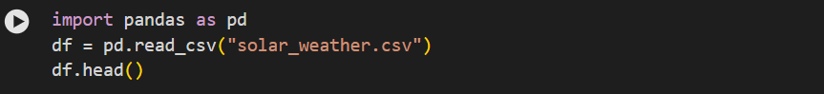

Appendix 1: Loading the Dataset

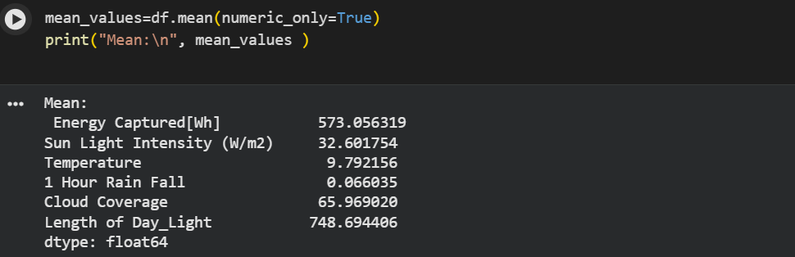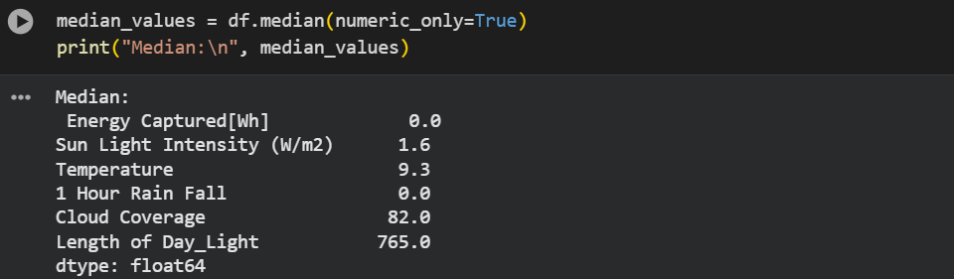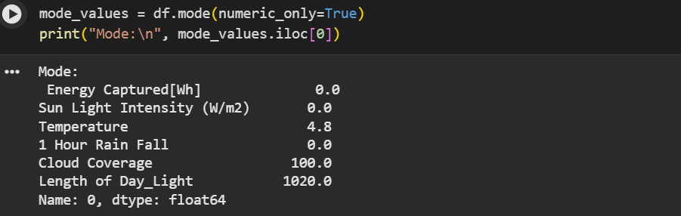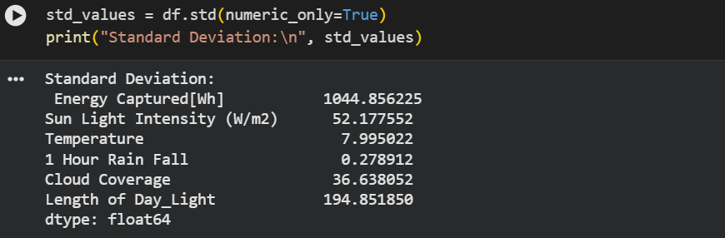

Appendix 2: Calculating Descriptive Statistics

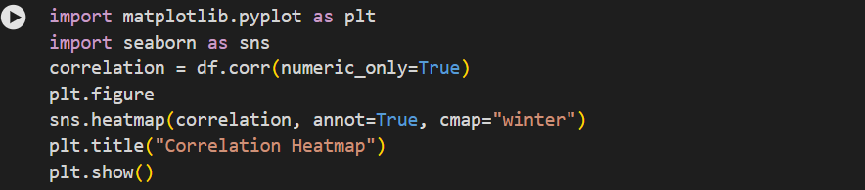

Appendix 3: Correlation Heatmap

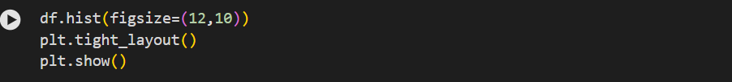

Appendix 4: Frequency Distribution Plots

Task 2
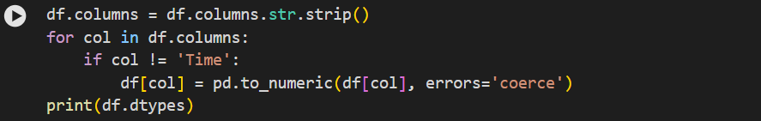

Appendix 5: Handling Column Formatting and Numeric Conversion of Columns

Appendix 6: Handling Missing Values

Task 3
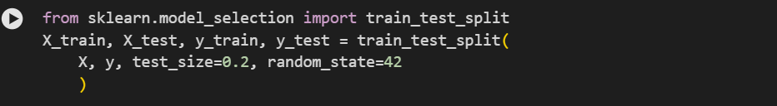

Appendix 7: Train-Test Split (80/20)

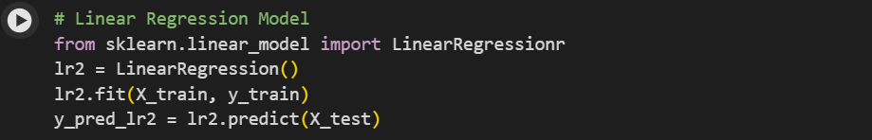

Appendix 8: Linear Regression Model

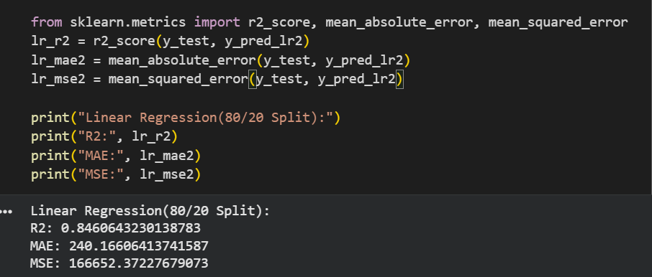

Appendix 9: Calculating R2, MAE, MSE for Linear Regression Model

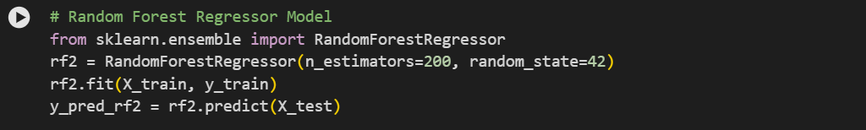

Appendix 10: Random Forest Regression Model

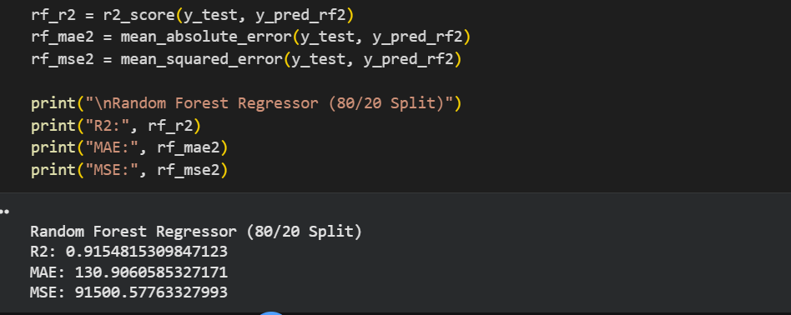

Appendix 11: Calculating R2, MAE, MSE for Random Forest Regression Model

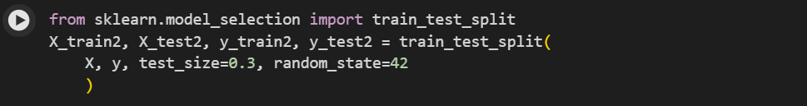

Appendix 12: Train-Test Split (70/30)

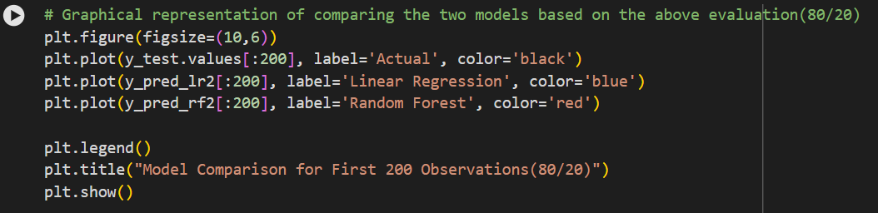

Appendix 13: Comparing Two Models Through Graphical Representation

Task 4
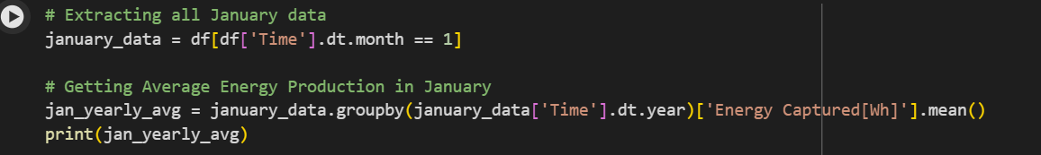

Appendix 14: Extracting January Data

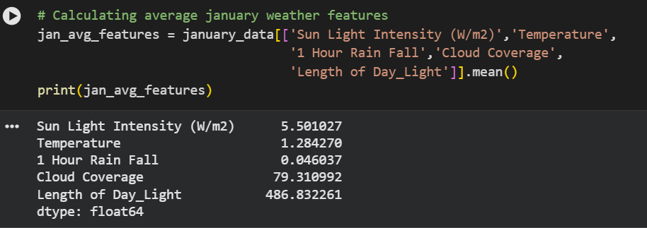

Appendix 15: Calculating January Annual Weather

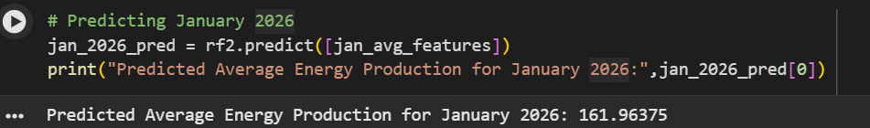

Appendix 16: Predicting January 2026

LIST OF TABLES AND FIGURES

Figure 1: Correlation Heatmap of Solar Energy Variables 11
Figure 2: Frequency Distribution of Key Variables 12
Figure 3: Dataset Data Types Before Conversion 14
Figure 4: Dataset Data Types After Numeric Conversion 15
Figure 5: Missing Values Identified After Numeric Conversion 16
Figure 6: Final Cleaned Dataset 16
Figure 7: Boxplot Showing Extreme Energy Values 17
Figure 8: Correlation matrix showing relationships between weather variables and energy captured 18
Figure 9: Comparison of actual energy production with Linear Regression and Random Forest predictions (80/20 split). 21

Table 1: Descriptive Statistics of Solar Energy Dataset (2017–2022) 9
Table 2: Performance Comparison of Models (80/20 Split) 19
Table 3: Performance Comparison of Models (70/30 Split) 20
Table 4: Average January Energy Production Comparison 22

GOOGLE COLAB

Task 1 and Task 2: https://colab.research.google.com/drive/1kJviLehSJpJ44Lheg1RkN3U__VweEGnt?usp=sharing
Task 3 and Task 4:
https://colab.research.google.com/drive/17C26CoOIk_4H9UBU5eUz_eBV7Ag42X20?usp=sharing

